Smart Classroom Technology

Multimedia training manual

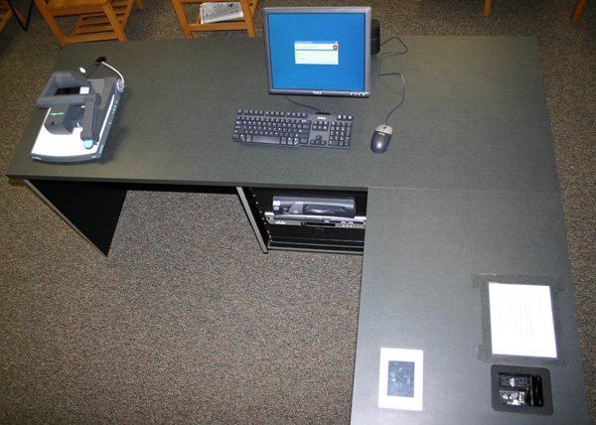

Applies to:
Winston 001 Winston 004 Winston 017
Tompkins123

Table of Contents

I. INTRODUCTION
A. THE CLASSROOM…………………………………………………………... | 2
B. TOUCH SCREEN CONTROL PANEL………...……………………………. | 3-4
C. CABLE CUBBY…………...…………………………………………………. | 5
II. USING THE SYSTEM
A. LAPTOP………………………………………………………………………. | 6
B. LAPTOP CONNECTION AND DISPLAY SETTINGS………...…………... | 7
C. DESKTOP COMPUTER……………………………………………………... | 8
D. DOCUMENT CAMERA……………………………………………………... | 9
E. DOCUMENT CAMERA CONTROLS………………………………………. | 10
F. DVD/VCR…………………………………………………………………….. | 11-12
G. PROGRAM AUDIO…………………………………………………………. | 13
H. Playing Audio CD……………….………………………..…………………… | 14
I. TURNING THE SYSTEM OFF……………………………………………… | 15
III. HELP AND FEEDBACK………………………………………………………... | 16

Introduction

The Classroom

This multimedia classroom incorporates a variety of resources to empower you to deliver engaging classroom activities. This packet guides you through the operation of all features and functions of the equipment as well as ways to request assistance when necessary.

The following equipment has been installed in this classroom:

• Ceiling-mounted data/video projector
• Laptop input capability
• Computer with DVD/CD-RW drive, LCD monitor on articulating arm
• Visual Presenter/Document Camera
• DVD/VCR unit
• Sound system for program playback.
• Touch Panel Control System
• Whiteboards in many of the rooms, that serve to reduce the amount of dust the equipment is exposed to as well as increase contrast for the visually impaired

It is our goal to provide you with quick and effective support anytime you encounter a problem or difficulty of any kind with the room. Please call CHASS Computer Services at 515-3512 and we will address any problems as soon as possible.

Touch Screen Control Panel

To begin using the system, go first to the Control Panel seen in the image below. To start the system, you must first tap the screen to wake up the touch screen. Once the screen has refreshed, press the On button located on the touch screen in the lower right corner.
This will turn on the projector. The system will need approximately 30 seconds to warm- up.

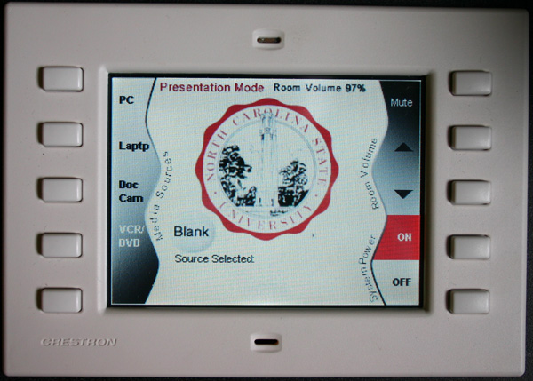

Touch Screen Control Panel

Once you have turned the system on, select the input you would like to use by pressing the appropriate box on the touch screen. The Control Panel will allow you to choose the following equipment options:

• PC
• Laptop
• Doc Cam
• VCR/DVD

Only one piece of equipment can be utilized at a time. In other words, if you wish to switch from showing a Power Point presentation from the laptop to a video on the DVD player you must select DVD which in turn will prevent the Power Point from being visible. To return to the Power Point you must go back and select laptop again on the touch screen.
The volume controls are located on the right side of the touch panel screen.

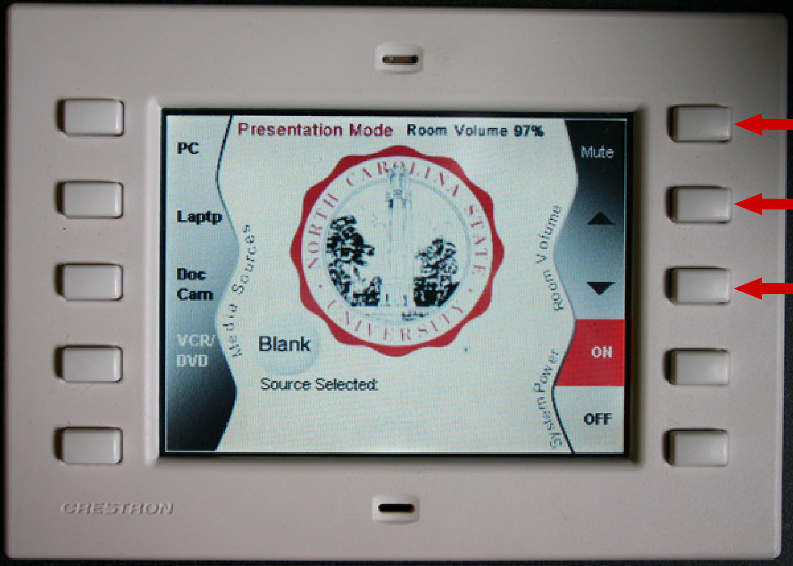

Touch Screen Control Panel
Cable Cubby

The cable cubby is located on the surface of the lectern. It contains 2 electrical
outlets, 1 audio cable, 1 VGA cable for connecting laptop display, 2 network cables (labeled Nomad or Building),and 1 USB cable connected to the PC.

To connect to the campus network:
There are two ways to connect to the campus network. If your laptop is registered in that building (if you have an office in the building), you may use the cable labeled BUILDING. If not, plug in the cable labeled NOMAD and open up your favorite browser and authenticate with your Unity ID and password.

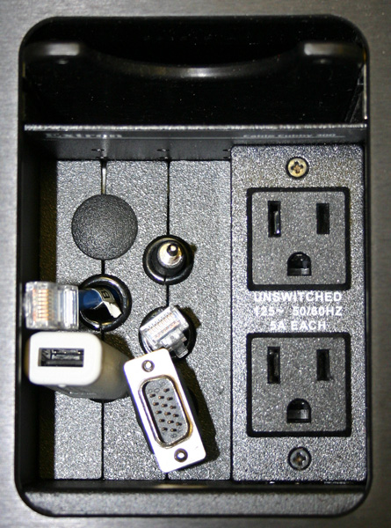

Open Cable Cubby

Using the System

Laptop
1. Press the On button located on the touch screen in the lower right corner.
2. Plug your laptop in and turn it on. (See diagram)

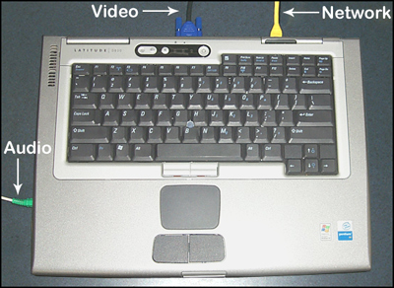
Diagram: Laptop Setup

3. Press Laptop on the Control Panel (2nd button on Left).

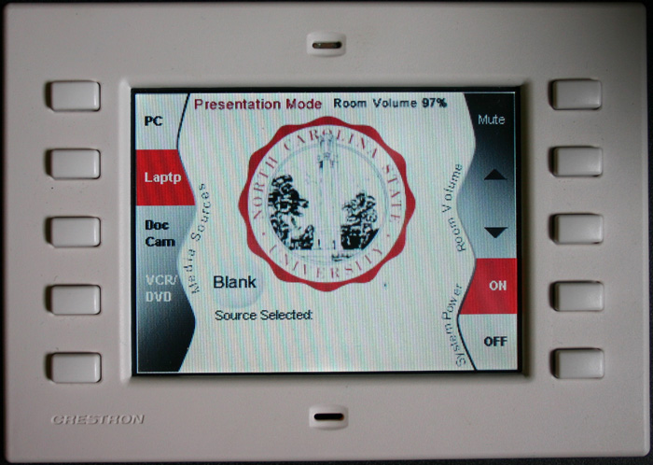

Control Panel with Laptop Highlighted
Laptop Connection and Display Settings

To set the laptop to display on the Projector:
Make sure the laptop is plugged in properly and the projector is on. To change the display you must press the Function (FN) key on your laptop, along with a second key as noted in the table below.

Compaq: | FN+F2
Dell: | FN+F8 or FN+F12
Gateway: | FN+F3
IBM: | FN+F7
Micron: | FN +F2 or FN+F12

If your laptop is not one of the brands listed above, or if you are having problems switching displays, please call CHASS Computing at 515-3512.

Desktop Computer

1. Press the On button located on the touch screen in the lower right corner.
2. Press PC on the touch screen panel. It is the 1st top button on the Left.
3. Login to the computer using your Social ID or Unity ID and password.
Please have patience as the machine logs you in. It may take several minutes for this process to complete.
4. Remember to logoff when you are done.

You may bring in CD’s, DVD’s or 3.5” floppy diskettes to be played on the PC. In addition, this computer has two USB ports on the front and one located in the cable cubby for other multimedia devices such as a USB portable drive, USB card reader or USB zip drive.

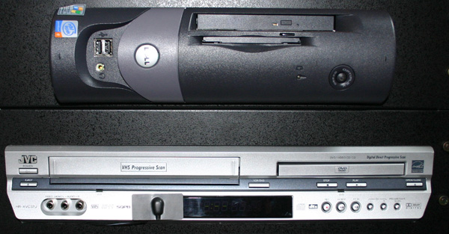

Document Camera

1. Press the On button located on the touch screen in the lower right corner.
2. Press Doc Cam on the touch screen (3rd button down on Left side).
3. Gently lift the green handle located on the arm of the document camera. Extending the arm fully will turn the Document Camera on automatically.
4. Place your document or object on the surface of the presenter face up.
5. Use the controls on the front of the camera to adjust the projected image.
6. When you are finished using the Document Camera remember to lower the arm and turn off the unit by pressing the power button located on the right side of the unit.

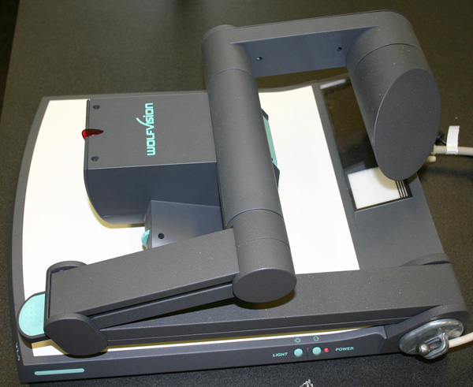

Please see the following page for instructions on using the Document Camera Controls.
Document Camera Controls

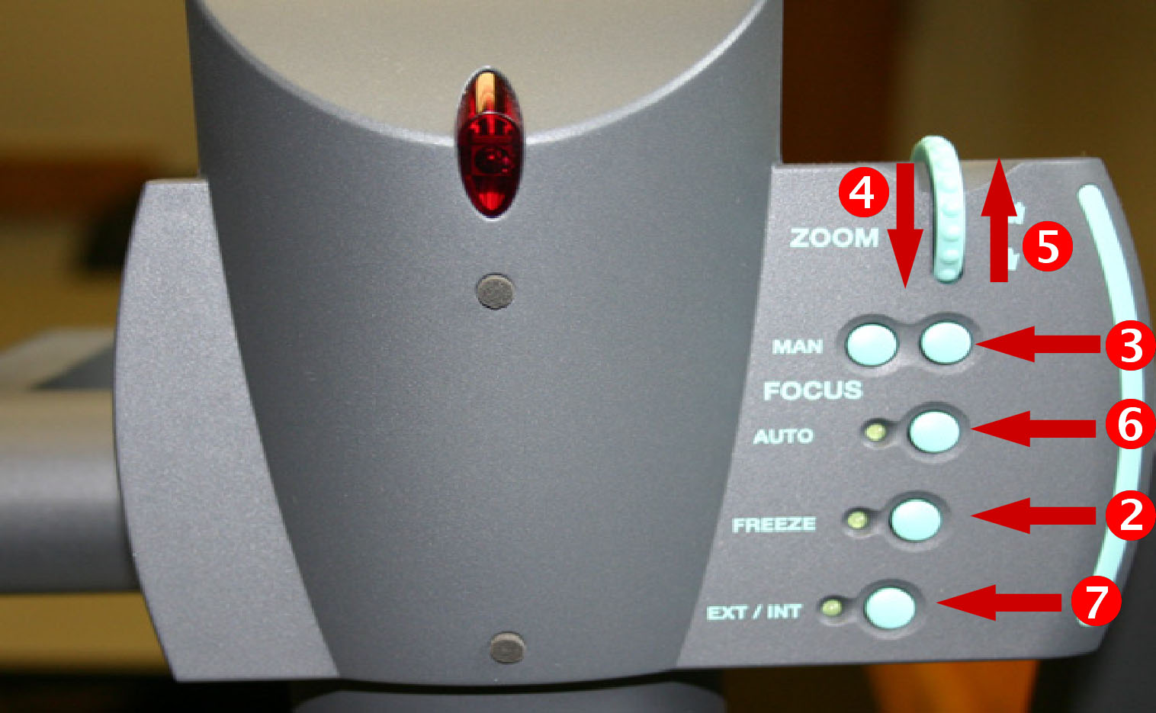

(1) Power | Turns the camera on and off
(2) Freeze | Takes a still image of what the camera is displaying. Any changes made to the object will not be seen until the picture is “unfrozen”.
(3) MAN | Manually focus the projector for fine focusing.
(4) Zoom In | Simulates movement closer to the object being displayed.
(5) Zoom Out | Simulates movement away from the object being displayed.
(6) Auto | Auto Focus adjusts the focus of the image automatically.
(7) INT/EXT | Toggles the video being sent to the projector

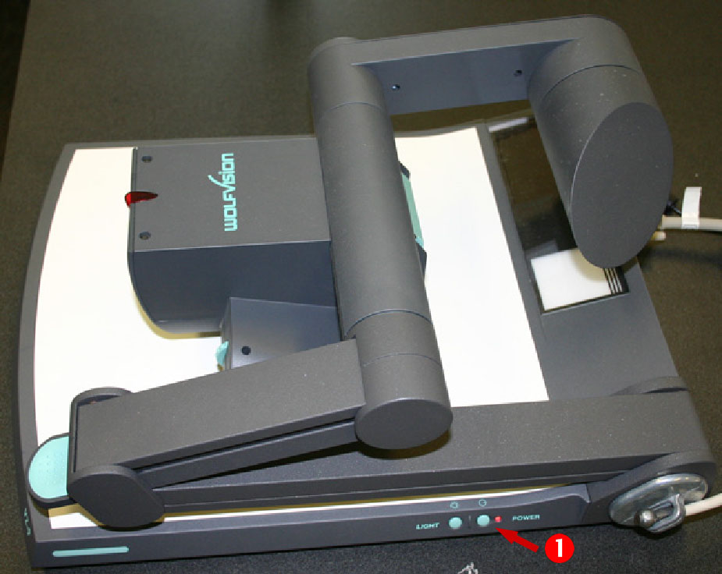

.
DVD/VCR
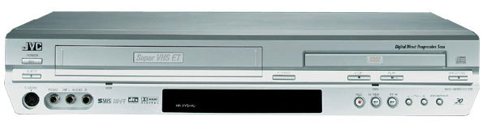

DVD/VCR Playback
1. Press the On button located on the touch screen in the lower right corner.
2. Press DVD/VCR (4th button on the left).
3. Gently insert DVD or VHS tape into the unit; it will power up and switch to the correct mode automatically.
4. Control playback using the control pad.(Below)

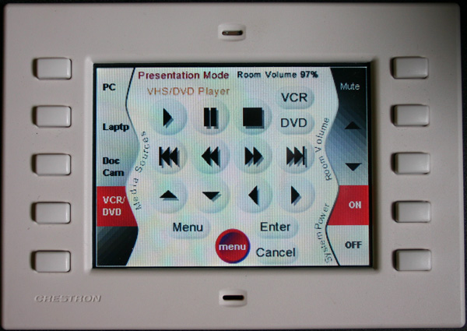
Playback Control Pad

Switching between VCR and DVD mode
To toggle between VCR mode and DVD mode, press the button on the upper right portion of the touch screen corresponding to the mode you want to use.

Program Audio

1. Press the On button located on the touch screen in the lower right corner.
2. Connect the lectern’s audio cable to the audio source. Examples of this are MP3 players, Audio tape players, Laptops.
3. Begin playback of the audio source.
4. Use the volume buttons to adjust the audio level.

Playing an Audio CD
From the Computer
- Press the On button located on the touch screen in the lower right corner.
- Press PC on the touch screen panel. It is the 1st top button on the Left.
- Login to the computer using your Social ID or Unity ID and password.
- Open the CD tray on the computer by pressing the button located on the center of the CD tray.
- Insert your CD and close the CD tray.
- Open the My Computer icon on the Desktop and and then open the icon for the CD drive.
- An Application either Windows Media Player or Real Player will startup automatically.

Playing an Audio CD
From the DVD player
- Press the On button located on the touch screen in the lower right corner.
- Press DVD/VCR on the touch screen panel.4th button on the left.
- Press the DVD button on the upper right portion of the screen.
- Open the DVD tray on the DVD player insert the Audio CD.
- Using the touch screen controls press the play button to start the CD.

Turning the system off

1. Press the Off button located on the touch screen in the lower right corner.
2. Press Yes on the “Are you sure you want to shut down and exit this system screen”.
3. Don’t forget to take your VCR tape, CD or DVD with you if you brought one.
4. If you logged onto the PC, don’t forget to logoff. It is critical to log off the PC at the end of the session because anyone can access the files you have on your U drive for Social accounts or K drive for Unity accounts.

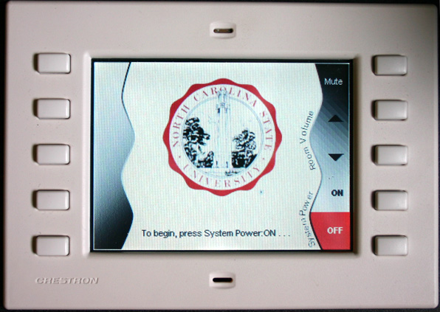

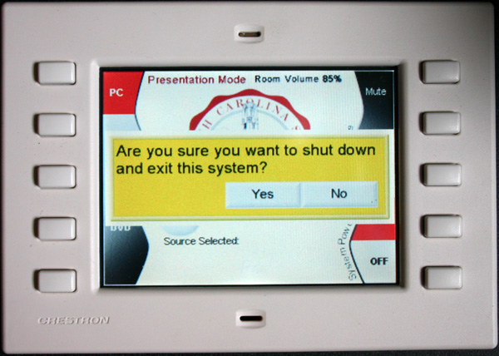
Help and Feedback

CHASS Computing recommends that you practice with the equipment and media you wish to use ahead of a class presentation, this will allow you to work out any difficulties prior to your presentation. However, if you have difficulties during class, please call us. If we cannot solve the problem over the phone, please specify whether or not a technician may interrupt your class to solve the problem for you.

CHASS Computing Services would like to hear from you anytime you discover an opportunity for improvement to this facility. Our staff would also like to hear from you about your classroom audio-visual needs, whether it be this room or another room on campus, as well as how improvements might better enable you to meet your teaching goals. If you have any suggestions, please e-mail us at chasscs@social.chass.ncsu.edu.

Phone: 515-3512

